

INTERNATIONAL ISLAMIC UNIVERSITY MALAYSIA

INFO 2203

Database Programming

Project

Restaurant Management System

1. **Khan Nasik Sami 1638153**
2. **Zian Md Afique Amin 1631005**
3. **MD Sariful Islam 16266674.**
4. **Abrar Habib Haque 1636029**

**1.0 Project Background**

Our team is going to make a system and it's title is "Restaurant Management System". In this system, there will be 6 tables. Namely Customer, Manager, Restaurant, Payment, Food_Items and Booking. These tables will have relations and cardinality among themselves. Which is given in the Entity Relation (ER) Diagram below. Basically, we are going to create a system where there will be many restaurants under our supervision in different locations. The menu is similar for all of them. The customer can book his/her order and there will be Eat In and Take Away options. We will work as the bridge between the customer and restaurants. Something similar to what the caterers do. In this project we will populate the tables mentioned above with many relevant values and try to execute various queries and PL sql functions, procedure and cursor. In the later part we will try to make a web application that can interact with the database.

**2.0 CONCEPTUAL DATABASE DESIGN**  
  
**Entity-Relationship Model**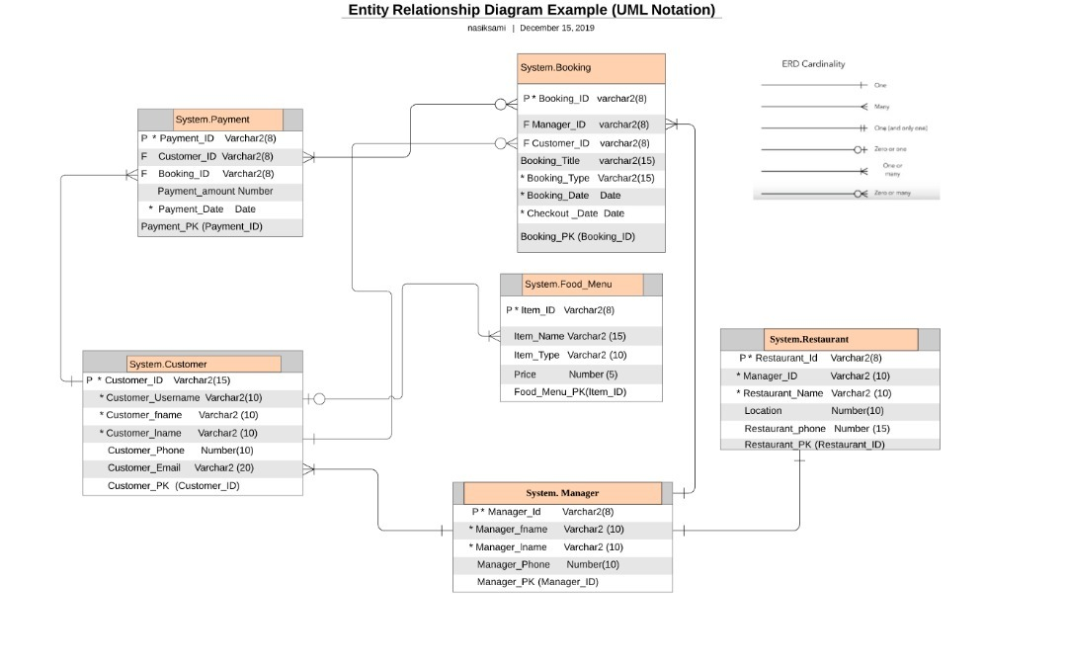

**3.0 DATA DICTIONARY FOR ER DIAGRAM  
  
Data Dictionary**  
  
**Customer**

|  |  |  |  |
| --- | --- | --- | --- |
| Attribute Name | Data Type | Size | NULL |
| Customer_Id(PK) | VARCHAR2 | 8 | NO |
| Customer_Username | VARCHAR2 | 15 | NO |
| Customer_fname | VARCHAR2 | 15 | NO |
| Customer_lname | VARCHAR2 | 10 | NO |
| Customer_Phone | NUMBER | 15 | YES |
| Customer_Email | VARCHAR2 | 20 | YES |
| Item_ID | VARCHAR2 | 8 | NO |

**Restaurant**

|  |  |  |  |
| --- | --- | --- | --- |
| Attribute Name | Data Type | Size | NULL |
| Restaurant_Id(PK) | NUMBER | 8 | NO |
| Manager_Id(FK) | NUMBER | 8 | NO |
| Restaurant_Name | VARCHAR2 | 15 | NO |
| Location | VARCHAR2 | 15 | YES |
| Restaurant_Phone | NUMBER |  | YES |

**Booking**

|  |  |  |  |
| --- | --- | --- | --- |
| Attribute Name | Data Type | Size | NULL |
| Booking_Id(PK) | NUMBER | 8 | NO |
| Manager_Id(FK) | NUMBER | 8 | NO |
| Customer_Id(FK) | VARCHAR2 | 8 | NO |
| Booking_Title | VARCHAR2 | 15 | YES |
| Booking_Type | VARCHAR2 | 15 | NO |
| Booking_Date | DATE |  | NO |
| Checkout_Date | DATE |  | NO |

**Manager**

|  |  |  |  |
| --- | --- | --- | --- |
| Attribute Name | Data Type | Size | NULL |
| Manager_Id(PK) | NUMBER | 8 | NO |
| Manager_fname | VARCHAR2 | 10 | NO |
| Manager_lname | VARCHAR2 | 10 | NO |
| Manager_Phone | NUMBER | 15 | YES |

**Payment**

|  |  |  |  |
| --- | --- | --- | --- |
| Attribute Name | Data Type | Size | NULL |
| Payment_Id(PK) | NUMBER | 8 | NO |
| Customer_Id(FK) | VARCHAR2 | 8 | NO |
| Booking_Id(FK) | NUMBER | 8 | NO |
| Payment_Amount | NUMBER |  | NO |
| Payment_Date | DATE |  | NO |

**Food_Menu**

|  |  |  |  |
| --- | --- | --- | --- |
| Attribute Name | Data Type | Size | NULL |
| Item_Id(PK) | VARCHAR2 | 8 | NO |
| Item_Name | VARCHAR2 | 15 | YES |
| Item_Type | VARCHAR2 | 10 | YES |
| Price | NUMBER | 4 | YES |

**User Creation:**

SQL> conn

Enter user-name: SYSTEM

Enter password:

Connected.

SQL> conn sys as sysdba;

Enter password:

Connected.

SQL> conn

Enter user-name: hr

Enter password:

ERROR:

ORA-28000: the account is locked

Warning: You are no longer connected to ORACLE.

SQL> alter user hr identified by hr account unlock;

SP2-0640: Not connected

SQL> conn sys as sysdba

Enter password:

Connected.

SQL> create user project identified by project;

User created.

SQL> grant dba to assignment1;

Grant succeeded.

SQL> commit;

Commit complete.

**4.0 PHYSICAL DATABASE DESIGN**  
  
**Create and drop table**   
  
drop table Booking cascade constraints;

drop table Customer cascade constraints;

drop table Restaurant cascade constraints;

drop table Manager cascade constraints;

drop table Payment cascade constraints;

drop table Food_Menu cascade constraints;

create table Customer

(Customer_Id varchar2(8),

Customer_Username varchar2(15) not null,

Customer_fname varchar2(15) not null,

Customer_lname varchar2(10) not null,

Customer_Phone number(15),

Customer_Email varchar2(20),

Item_ID varchar2(8),

primary key(Customer_Id),

foreign key(Item_ID) references Food_Menu(Item_ID));

create table Restaurant

(Restaurant_Id number(8),

Manager_Id number(8),

Restaurant_Name varchar2(15) not null,

Location varchar2(15),

Restaurant_Phone number,

primary key (Restaurant_Id));

create table Booking

(Booking_Id number(8),

Manager_Id number(8),

Customer_Id varchar2(8),

Booking_Title varchar2(15),

Booking_Type varchar2(15) not null,

Booking_Date date not null,

Checkout_Date date not null,

primary key(Booking_Id),

foreign key(Manager_Id) references Manager(Manager_Id),

foreign key(Customer_Id) references Customer(Customer_Id));

create table Manager

(Manager_Id number(8) ,

Manager_fname varchar2(10) not null,

Manager_lname varchar2(10) not null,

Manager_Phone number(15),

primary key(Manager_Id));

create table Payment

(Payment_Id number(8),

Customer_Id varchar2(8),

Booking_Id number(8),

Payment_Amount number,

Payment_Date date not null,

primary key (Payment_Id),

foreign key (Customer_Id) references Customer(Customer_Id),

foreign key (Booking_Id) references Booking(Booking_Id));

create table Food_Menu

(Item_ID varchar2(8) not null,

Item_Name varchar2(15) null,

Item_Type varchar2(10),

Price number(4),

primary key (Item_ID));

**5.0 SCRIPT TO POPULATE TABLE**  
  
insert into customer values(166777,'Mokles','Md','Sarif',0176322,'jizzi@gmail.com','I02');

insert into customer values(162324,'Zalali','Akash','Ahmad',0276623,'kiz86i@gmail.com','I05');

insert into customer values(162352,'Jib','Nasik','Sami',0176232,'nasikii@gmail.com','I09');

insert into customer values(167865,'Fel','Zian','Ali',0176644,'afiquezian@gmail.com','I10');

insert into customer values(186542,'Saap','Janwar','Sani',0276452,'janwar@gmail.com','I12');

insert into customer values(153766,'Bolod','Tawsif','Mia',0136754,'chor@gmail.com','I12');

insert into customer values(163322,'Makkhi','Amir','Saki',0143652,'sadia@gmail.com','I12');

insert into customer values(122233,'Gadha','Meem','Dota',0123392,'maal@gmail.com','I02');

insert into customer values(164322,'humby','Gerave','Rai',0156652,'ji232ii@gmail.com','I01');

insert into customer values(163221,'Iot','Md','Sarif',0164905,'jiuuh@gmail.com','I05');

insert into manager values(126777,'Rojaro','shen',112755);

insert into manager values(136625,'Rojaro','Alim',113725);

insert into manager values(146729,'Robert','Smith',236955);

insert into manager values(128762,'Micle','Ubala',446555);

insert into manager values(134331,'Eka','kappor',114325);

insert into manager values(114231,'Baal','Saad',142455);

insert into manager values(104532,'Hero','Alom',134229);

insert into manager values(136988,'Joya','Ahsan',129325);

insert into manager values(122558,'Abul','Hayat',543200);

insert into manager values(119577,'Murad','Takla',985321);

insert into manager values(164332,'Sanai','Takla',114235);

insert into manager values(124556,'Joya','Ubala',114325);

insert into manager values(744342,'Mujib','Ali',117625);

insert into booking values(156331,126777,163221,'Indian','Eatin',to_date('25-DEC-19'),to_date('28-DEC-19'));

insert into booking values(166666,114231,164322,'Western','Take Away',to_date('25-DEC-19'),to_date('27-DEC-19'));

insert into booking values(152341,744342,122233,'Malay','Eatin',to_date('22-NOV-19'),to_date('24-NOV-19'));

insert into booking values(296651,164332,163322,'Western','Take Away',to_date('02-DEC-19'),to_date('08-DEC-19'));

insert into booking values(656331,122558,153766,'Indian','Take Away',to_date('24-DEC-19'),to_date('26-DEC-19'));

insert into booking values(199331,128762,186542,'Malay','Eatin',to_date('24-DEC-19'),to_date('25-DEC-19'));

insert into booking values(185331,744342,167865,'Western','Eatin',to_date('02-DEC-17'),to_date('08-DEC-17'));

insert into booking values(136391,126777,162352,'Indian','Take Away',to_date('29-NOV-18'),to_date('30-NOV-18'));

insert into booking values(198331,122558,162324,'Malay','Eatin',to_date('26-NOV-17'),to_date('29-NOV-17'));

insert into booking values(189766,124556,166777,'Western','Take Away',to_date('27-FEB-18'),to_date('01-MAR-18'));

insert into booking values(876623,136625,166777,'Indian','Eatin',to_date('28-AUG-18'),to_date('02-SEP-18'));

insert into Restaurant values(987755,126777,'Restaurant Taj','Gombak',655422);

insert into Restaurant values(988772,136625,'Restaurant Mihh','Idaman',655222);

insert into Restaurant values(163265,146729,'Marks','Selangor',152443);

insert into Restaurant values(875542,128762,'Plaza UU','Gombak',652222);

insert into Restaurant values(692553,134331,'Yumi Ila','Idaman',324229);

insert into Restaurant values(765430,114231,'Restaurant Juyy','Idaman',298554);

insert into Restaurant values(987654,104532,'Restaurant Maya','Langkawi',652422);

insert into Restaurant values(987751,136988,'Restaurant Syl','Sylhet',651232);

insert into Restaurant values(982555,122558,'Restaurant Taj','Sylhet',611422);

insert into Restaurant values(895442,124556,'HT Mango','Langkawi',987722);

insert into Restaurant values(111111,744342,'Restaurant Miz','Sylhet',265122);

insert into payment values(654423,166777,156331,3150,to_date('02-MAR-19'));

insert into payment values(654421,162324,166666,1950,to_date('21-MAR-19'));

insert into payment values(621123,167865,152341,null,to_date('25-JAN-19'));

insert into payment values(554423,162352,296651,8400,to_date('28-FEB-19'));

insert into payment values(123123,186542,656331,null,to_date('25-FEB-19'));

insert into payment values(786524,153766,199331,850,to_date('27-FEB-19'));

insert into payment values(907699,163322,185331,8500,to_date('25-APR-17'));

insert into payment values(623313,122233,136391,1300,to_date('30-JUL-18'));

insert into payment values(234567,164322,198331,null,to_date('01-APR-71'));

insert into Food_Menu values('I01','Pizza','western', 30);

insert into Food_Menu values('I02','Burger','western', 10);

insert into Food_Menu values('I03','Pasta','western', 15);

insert into Food_Menu values('I04','Shwarma','western', 5);

insert into Food_Menu values('I05','Nasi Ayam','malay', 6);

insert into Food_Menu values('I06','Nasi Lemak','malay', 7);

insert into Food_Menu values('I07','Nasi Goreng Pataya','malay', 6);

insert into Food_Menu values('I08','Ayam kunit','malay', 5);

insert into Food_Menu values('I09','Roti Canai','indian', 8);

insert into Food_Menu values('I10','Tanduri','indian', 6);

insert into Food_Menu values('I11','Biryani','indian', 10);

insert into Food_Menu values('I12','Kacchi','indian', 12);

**6.0 QUERY, ADD, REMOVE, INSERT & MODIFY DATA   
  
Value insert in customer table**  
  
SQL> insert into customer values(166221,'Mojid','Orick','Ori',0164105,'oori@gmail.com','I09');

1 row created.

**Normal Select Statement to see the details of customers**

SQL> select * from customer;

CUSTOMER CUSTOMER_USERNA CUSTOMER_FNAME CUSTOMER_L CUSTOMER_PHONE

-------- --------------- --------------- ---------- --------------

CUSTOMER_EMAIL ITEM_ID

-------------------- --------

164322 humby Gerave Rai 156652

ji232ii@gmail.com I01

162324 Zalali Akash Ahmad 276623

kiz86i@gmail.com I05

162352 Jib Nasik Sami 176232

nasikii@gmail.com I09

CUSTOMER CUSTOMER_USERNA CUSTOMER_FNAME CUSTOMER_L CUSTOMER_PHONE

-------- --------------- --------------- ---------- --------------

CUSTOMER_EMAIL ITEM_ID

-------------------- --------

167865 Fel Zian Ali 176644

afiquezian@gmail.com I10

186542 Saap Janwar Sani 276452

janwar@gmail.com I12

153766 Bolod Tawsif Mia 136754

chor@gmail.com I12

CUSTOMER CUSTOMER_USERNA CUSTOMER_FNAME CUSTOMER_L CUSTOMER_PHONE

-------- --------------- --------------- ---------- --------------

CUSTOMER_EMAIL ITEM_ID

-------------------- --------

163322 Makkhi Amir Saki 143652

sadia@gmail.com I12

122233 Gadha Meem Dota 123392

maal@gmail.com I02

163221 Iot Md Sarif 164905

jiuuh@gmail.com I05

CUSTOMER CUSTOMER_USERNA CUSTOMER_FNAME CUSTOMER_L CUSTOMER_PHONE

-------- --------------- --------------- ---------- --------------

CUSTOMER_EMAIL ITEM_ID

-------------------- --------

166777 Mokles Md Sarif 176322

jizzi@gmail.com I02

166221 Mojid Orick Ori 164105

oori@gmail.com I09

11 rows selected. **Select Statement to find people with certain first name**

SQL> select customer_id,customer_fname,customer_lname from customer where customer_fname='Akash';

CUSTOMER CUSTOMER_FNAME CUSTOMER_L

-------- --------------- ----------

162324 Akash Ahmad

**Finding Restaurants from same location using Join**

SQL> select restaurant_id,restaurant.manager_id, restaurant_name,location

2 from restaurant,manager

3 where location='Sylhet' AND restaurant.manager_id= manager.manager_id;

RESTAURANT_ID MANAGER_ID RESTAURANT_NAME LOCATION

------------- ---------- --------------- ---------------

987751 136988 Restaurant Syl Sylhet

982555 122558 Restaurant Taj Sylhet

111111 744342 Restaurant Miz Sylhet

**Finding the bill of a certain person using Join (Condition: Name= Md Sarif)**

SQL> select customer.customer_id,customer_fname,customer_lname,booking_id,

2 booking_date,checkout_date,customer.Item_id,Item_name,Item_type,

3 price from customer, booking,food_menu

4 Where customer.customer_id= booking.customer_id AND

5 customer.Item_ID=food_menu.item_Id AND customer_fname='Md' AND

6 customer_lname='Sarif';

CUSTOMER CUSTOMER_FNAME CUSTOMER_L BOOKING_ID BOOKING_D CHECKOUT_ ITEM_ID

-------- --------------- ---------- ---------- --------- --------- --------

ITEM_NAME ITEM_TYPE PRICE

--------------- ---------- ----------

163221 Md Sarif 156331 25-DEC-19 28-DEC-19 I05

Nasi Ayam malay 6

166777 Md Sarif 189766 27-FEB-18 01-MAR-18 I02

Burger western 10

166777 Md Sarif 876623 28-AUG-18 02-SEP-18 I02

Burger western 10

**Finding the Restaurant name and location of a manager’s Restaurant using subquery**

SQL> select restaurant_name, location,restaurant_phone as contact from restaurant

2 where manager_id=(select manager_id from manager

3 where manager_fname='Mujib' AND manager_lname='Ali');

RESTAURANT_NAME LOCATION CONTACT

--------------- --------------- ----------

Restaurant Miz Sylhet 265122  
  
  
  
  
**Update a table to change a value**

SQL> select * from customer;

CUSTOMER CUSTOMER_USERNA CUSTOMER_FNAME CUSTOMER_L CUSTOMER_PHONE

-------- --------------- --------------- ---------- --------------

CUSTOMER_EMAIL ITEM_ID

-------------------- --------

164322 humby Gerave Rai 156652

ji232ii@gmail.com I01

162324 Zalali Akash Ahmad 276623

kiz86i@gmail.com I05

162352 Jib Nasik Sami 176232

nasikii@gmail.com I09

CUSTOMER CUSTOMER_USERNA CUSTOMER_FNAME CUSTOMER_L CUSTOMER_PHONE

-------- --------------- --------------- ---------- --------------

CUSTOMER_EMAIL ITEM_ID

-------------------- --------

167865 Fel Zian Ali 176644

afiquezian@gmail.com I10

186542 Saap Janwar Sani 276452

janwar@gmail.com I12

153766 Bolod Tawsif Mia 136754

chor@gmail.com I12

CUSTOMER CUSTOMER_USERNA CUSTOMER_FNAME CUSTOMER_L CUSTOMER_PHONE

-------- --------------- --------------- ---------- --------------

CUSTOMER_EMAIL ITEM_ID

-------------------- --------

163322 Makkhi Amir Saki 143652

sadia@gmail.com I12

122233 Gadha Meem Dota 123392

maal@gmail.com I02

163221 Iot Md Sarif 164905

jiuuh@gmail.com I05

CUSTOMER CUSTOMER_USERNA CUSTOMER_FNAME CUSTOMER_L CUSTOMER_PHONE

-------- --------------- --------------- ---------- --------------

CUSTOMER_EMAIL ITEM_ID

-------------------- --------

166777 Mokles Md Sarif 176322

jizzi@gmail.com I02

166221 Mojid Orick Ori 164105

oori@gmail.com I09

11 rows selected.

SQL> update customer

2 set customer_username='Borodhon'

3 where customer_fname='Zian'AND customer_lname='Ali';

1 row updated.

SQL> select * from customer;

CUSTOMER CUSTOMER_USERNA CUSTOMER_FNAME CUSTOMER_L CUSTOMER_PHONE

-------- --------------- --------------- ---------- --------------

CUSTOMER_EMAIL ITEM_ID

-------------------- --------

164322 humby Gerave Rai 156652

ji232ii@gmail.com I01

162324 Zalali Akash Ahmad 276623

kiz86i@gmail.com I05

162352 Jib Nasik Sami 176232

nasikii@gmail.com I09

CUSTOMER CUSTOMER_USERNA CUSTOMER_FNAME CUSTOMER_L CUSTOMER_PHONE

-------- --------------- --------------- ---------- --------------

CUSTOMER_EMAIL ITEM_ID

-------------------- --------

167865 Borodhon Zian Ali 176644

afiquezian@gmail.com I10

186542 Saap Janwar Sani 276452

janwar@gmail.com I12

153766 Bolod Tawsif Mia 136754

chor@gmail.com I12

CUSTOMER CUSTOMER_USERNA CUSTOMER_FNAME CUSTOMER_L CUSTOMER_PHONE

-------- --------------- --------------- ---------- --------------

CUSTOMER_EMAIL ITEM_ID

-------------------- --------

163322 Makkhi Amir Saki 143652

sadia@gmail.com I12

122233 Gadha Meem Dota 123392

maal@gmail.com I02

163221 Iot Md Sarif 164905

jiuuh@gmail.com I05

CUSTOMER CUSTOMER_USERNA CUSTOMER_FNAME CUSTOMER_L CUSTOMER_PHONE

-------- --------------- --------------- ---------- --------------

CUSTOMER_EMAIL ITEM_ID

-------------------- --------

166777 Mokles Md Sarif 176322

jizzi@gmail.com I02

166221 Mojid Orick Ori 164105

oori@gmail.com I09

11 rows selected.

**Delete values from a table**   
  
SQL> select * from payment;

PAYMENT_ID CUSTOMER BOOKING_ID PAYMENT_AMOUNT PAYMENT_D

---------- -------- ---------- -------------- ---------

654423 166777 156331 3150 02-MAR-19

654421 162324 166666 1950 21-MAR-19

621123 167865 152341 25-JAN-19

554423 162352 296651 8400 28-FEB-19

123123 186542 656331 25-FEB-19

786524 153766 199331 850 27-FEB-19

907699 163322 185331 8500 25-APR-17

623313 122233 136391 1300 30-JUL-18

234567 164322 198331 01-APR-71

9 rows selected.

SQL> delete from payment

2 where payment_amount>=8000;

2 rows deleted.

SQL> select * from payment;

PAYMENT_ID CUSTOMER_ID BOOKING_ID PAYMENT_AMOUNT PAYMENT_D

---------- ----------- ---------- -------------- ---------

621123 157865 152341 25-JAN-19

123123 176542 656331 25-FEB-19

786524 143766 199331 850 27-FEB-19

234567 154322 198331 01-APR-71

654423 156777 156331 3150 02-MAR-19

654421 152324 166666 1950 21-MAR-19

623313 112233 136391 1300 30-JUL-18

7 rows selected.

**Creating a view**  
  
SQL> create view manager_count

2 as select restaurant_id, manager_id, restaurant_name

3 from restaurant

4 order by manager_id DESC;

View created.

**Join a table with a view to find people with First Name Rojaro**

SQL> select * from (select m.manager_id,manager_fname,manager_lname,Restaurant_name

2 from manager_count l,manager m

3 where m.manager_id=l.manager_id AND manager_fname='Rojaro');

MANAGER_ID MANAGER_FN MANAGER_LN RESTAURANT_NAME

---------- ---------- ---------- ---------------

136625 Rojaro Alim Restaurant Mihh

126777 Rojaro shen Restaurant Taj  
  
  
  
  
  
  
  
  
**PROOCEDURES  
  
1.Sometimes customers change the checkout date of the Restaurant. Using this procedure the user can update the checkout date of a customer.**  
  
---------------------------------------------------------------------------------------------------------------------

create or replace procedure call(ID booking.booking_ID%TYPE,c_customer_id booking.customer_id%TYPE,newdate date) is

BEGIN

update booking

set booking_date=newdate

where booking_id=ID and customer_id=c_customer_id;

DBMS_OUTPUT.PUT_LINE('The data has updated');

END;

/

--ANONYMOUS BLOCK

--===========================

ACCEPT ID PROMPT 'Enter the booking ID: '

ACCEPT c_customer_id PROMPT 'Enter the Customer ID: '

ACCEPT newdate PROMPT 'Enter the new booking date: '

DECLARE

v_origdate booking.booking_date%type;

BEGIN

select booking_date

into v_origdate

from booking

where booking_id = '&ID'

and customer_id ='&c_customer_id';

call ('&ID', '&c_customer_id','&newdate');

DBMS_OUTPUT.PUT_LINE('Data updated ');

END;

/

---------------------------------------------------------------------------------------------------------------------  
Booking table before the updated checkout date

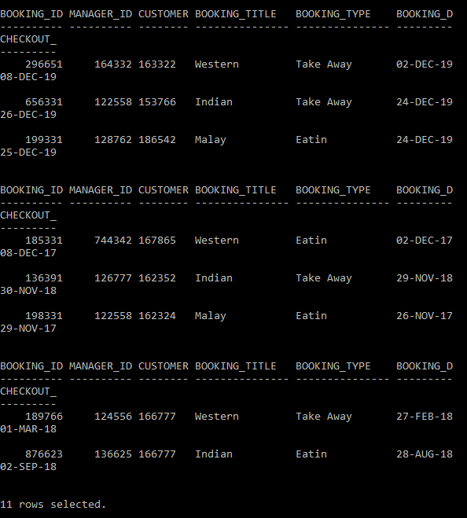

**7.0 Procedure Execution**

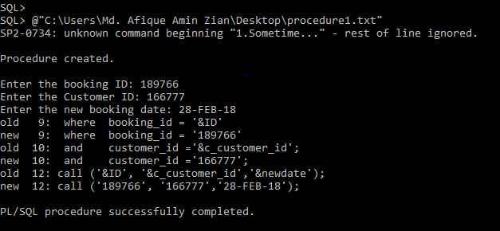 **Booking table after the Procedure**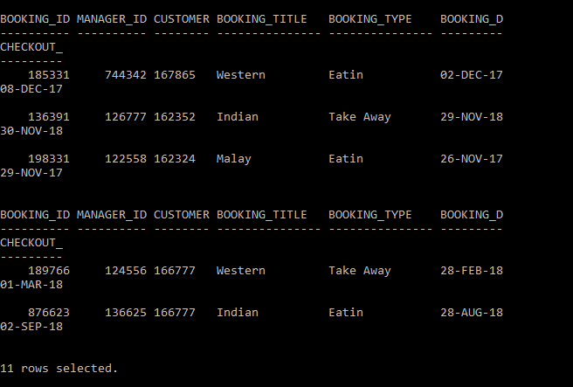

**2.This Procedure is used to see the details of a customer  
---------------------------------------------------------------------------------------------------------------------**create or replace procedure call2(c_customer_ID customer.customer_id%TYPE,c_customer_username customer.customer_username%TYPE) IS

fname varchar2(20);

lname varchar2(20);

phone number;

email varchar2(20);

BEGIN

select customer_fname,customer_lname,customer_phone,customer_email into fname,lname,phone,email

from customer

where c_customer_id=customer_id

AND c_customer_username=customer_username;

dbms_output.put_line('First Name: '||fname);

dbms_output.put_line('Last Name: '||lname);

dbms_output.put_line('Phone Number: '||phone);

dbms_output.put_line('Email: '||email);

end;

/

--ANONYMOUS BLOCK

--===========================

ACCEPT custID PROMPT 'Enter the customer ID: '

ACCEPT cust_username PROMPT 'Enter the Customer username: '

begin

call2('&custID','&cust_username');

dbms_output.put_line('THe data is successfully entered.');

end;

/

--------------------------------------------------------------------------  
**Procedure Execution**  
  
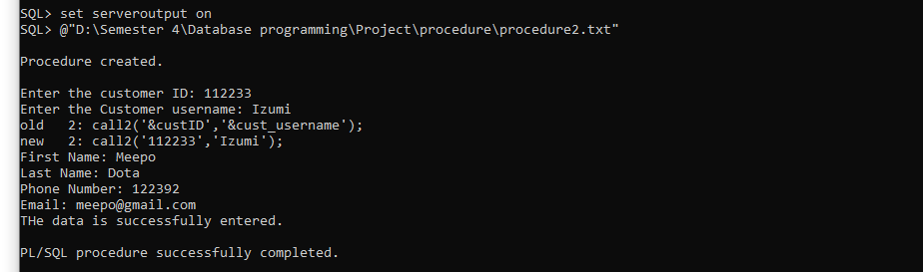

**3.Using this procedure the user can insert new values in the Restaurant table  
  
---------------------------------------------------------------------------------------------------------------------**create or replace procedure newval

(h_Restaurant_id Restaurant.Restaurant_id%TYPE,

h_manager_id Restaurant.manager_id%TYPE,

h_Restaurant_name Restaurant.Restaurant_name%TYPE,

h_location Restaurant.location%TYPE,

h_Restaurant_phone Restaurant.Restaurant_phone%TYPE

) IS

BEGIN

INSERT INTO Restaurant (Restaurant.Restaurant_id,Restaurant.manager_id,Restaurant.Restaurant_name,Restaurant.location,Restaurant.Restaurant_phone)

VALUES (h_Restaurant_id,h_manager_id,h_Restaurant_name,h_location,h_Restaurant_phone);

DBMS_OUTPUT.PUT_LINE('Data successfully added');

END;

/

--ANONYMOUS BLOCK

--===========================

ACCEPT h_Restaurant_id prompt 'ENTER RESTAURANT ID: '

ACCEPT h_manager_id prompt 'ENTER MANAGER ID: '

ACCEPT h_Restaurant_name prompt 'ENTER RESTAURANT NAME: '

ACCEPT h_location prompt 'ENTER LOCATION: '

ACCEPT h_Restaurant_phone prompt 'ENTER RESTAURANT PHONE NUMBER: '

BEGIN

newval('&h_Restaurant_id','&h_manager_id','&h_Restaurant_name','&h_location','&h_Restaurant_phone');

END;

/

--------------------------------------------------------------------------

**Restaurant table before Entering a new values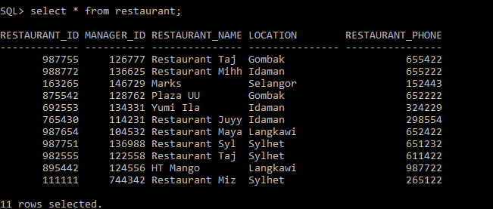 Procedure Execution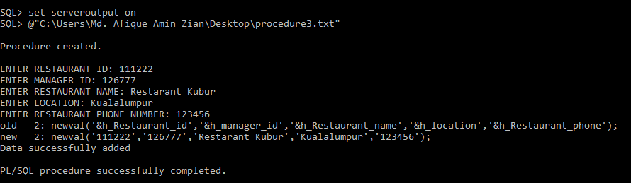 Restaurant Table after the execution of the procedure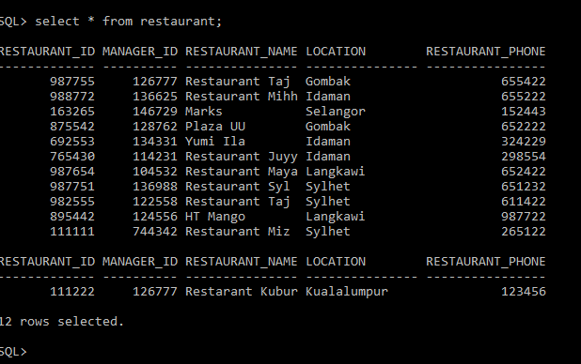 8.0 FUNCTIONS**

**1.Using this Function the user can see the bill of a certain customer. For the bill if the Restaurant is situated in Gombak, the bill will be multiplied by 1.4. If the Restaurant is situated in Idaman, the bill will be multiplied by 1.3. if the Restaurant is situated in Selangor, the bill will be multiplied by 1.6. if the Restaurant is situated in Sylhet, the bill will be multiplied by 1.8. if the Restaurant is situated in Langkawi, the bill will be multiplied by 2.**

**For the types of the food, the rent of the take away western food are 500 rm and the Indian and malay food 250 . If the food is eatin the price will be added by 10 and for the take away the price will be added by 15. This function will check the booking date and the checkout date of the customer and calculate the bill.  
---------------------------------------------------------------------------------------------------------------------**CREATE OR REPLACE FUNCTION citydisc

(p_id in number)

return number

is

price number;

p_type varchar2(12);

p_title varchar2(12);

p_bookingdate date;

p_checkoutdate date;

p_location varchar(12);

c_number number;

BEGIN

select booking_type,booking_title,checkout_date,booking_date,location into p_type,p_title,p_checkoutdate,p_bookingdate,p_location from booking join Restaurant on booking.manager_id=Restaurant.manager_id

AND (p_id=booking_id);

if p_location='Gombak' then c_number:=1.4;

elsif p_location='Idaman' then c_number:=1.3;

elsif p_location='Selangor' then c_number:=1.6;

elsif p_location='Sylhet' then c_number:=1.8;

elsif p_location='Langkawi' then c_number:=2;

end if;

if p_type='Eatin' AND p_title='Western' then price :=(10+500)*(p_checkoutdate-p_bookingdate)*c_number;

elsif p_type='Take Away' AND p_title='Western' then price:=(15+500)*(p_checkoutdate-p_bookingdate)*c_number;

elsif p_type='Eatin' AND p_title='Indian ' then price:=(10+250)*(p_checkoutdate-p_bookingdate)*c_number;

elsif p_type='Take Away' AND p_title='indian' then price:=(15+250)*(p_checkoutdate-p_bookingdate)*c_number;

elsif p_type='Take Away' AND p_title='Malay' then price:=(15+250)*(p_checkoutdate-p_bookingdate)*c_number;

elsif p_type='Eatin' AND p_title='Malay' then price:=(10+250)*(p_checkoutdate-p_bookingdate)*c_number;

end if;

return(price);

end;

/

--ANONYMOUS BLOCK

--===========================

ACCEPT p_id prompt 'Enter Booking ID:'

declare

p_id number;

BEGIN

p_id:=&p_id;

DBMS_OUTPUT.put_line

('Total Bill is : RM'||citydisc(p_id));

END;

/

**Function Execution**

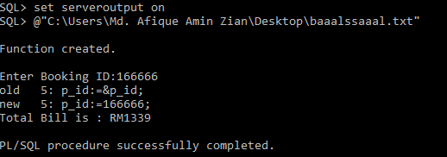

**2. Using this function the user will provide discount. If the User pays the before the checkout date he/she will get 20% discount. If the user pays the bill before 5 days after checkout, he/she will get 10% discount. If the user pays the bill after 5 days, he/she will get 5% discount  
  
---------------------------------------------------------------------------------------------------------------------**CREATE OR REPLACE FUNCTION discount1

(c_id in number)

return number

is

discount number;

p_checkoutdate date;

p_paymentdate date;

BEGIN

select checkout_date,payment_date into p_checkoutdate,p_paymentdate from booking join payment on payment.booking_id=booking.booking_id

AND (c_id=payment.booking_id);

if (p_paymentdate-p_checkoutdate)<0 then discount:=.2;

elsif (p_paymentdate-p_checkoutdate)>=0 AND (p_paymentdate-p_checkoutdate)<5 then discount:=.1;

elsif (p_paymentdate-p_checkoutdate)>5 then discount:=.05;

end if;

return(discount);

end;

/

--ANONYMOUS BLOCK

--===========================

ACCEPT c_id prompt 'Enter Booking ID:'

declare

c_id number;

BEGIN

c_id:=&c_id;

DBMS_OUTPUT.put_line

('Total Discount is '||discount1(c_id));

END;

/

**---------------------------------------------------------------------------------------------------------------------  
  
Function Execution**

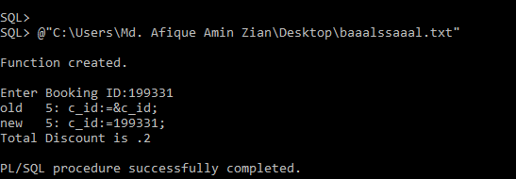 **9.0 CURSOR  
  
Implicit Cursor  
  
Using Cursor to delete Restaurants of certain location from Restaurant table  
  
---------------------------------------------------------------------------------------------------------------------**Set serveroutput on

BEGIN

DELETE FROM Restaurant

where location='Sylhet';

IF SQL%NOTFOUND THEN

DBMS_OUTPUT.PUT_LINE('No maching record');

ELSIF SQL%FOUND then DBMS_OUTPUT.PUT_LINE('DATA Successfully deleted');

END IF;

END;

/  
**---------------------------------------------------------------------------------------------------------------------  
Restaurant table before cursor execution**

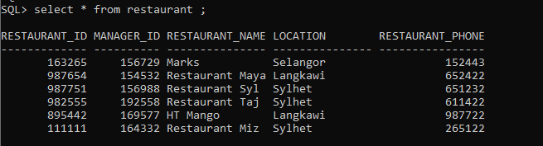

**Cursor Execution  
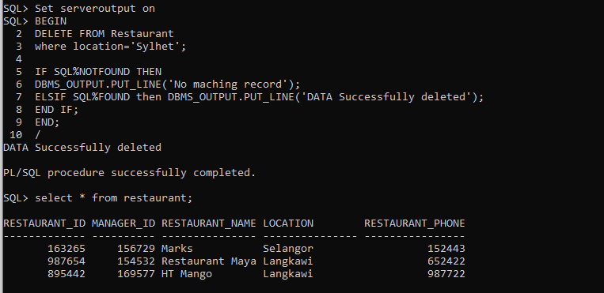  
Explicit Cursor  
  
Using cursor to see the customer id, first name and last name of the the first five customers from customer table  
  
---------------------------------------------------------------------------------------------------------------------**Declare

c_customer_id customer.customer_id%TYPE;

c_customer_FNAME customer.customer_fname%TYPE;

c_customer_LNAME customer.customer_lname%TYPE;

CURSOR customer_cursor IS

select customer_id,customer_fname,customer_lname

from customer;

BEGIN

OPEN customer_cursor;

LOOP

FETCH customer_cursor into c_customer_id,c_customer_FNAME,c_customer_LNAME;

EXIT WHEN customer_cursor%ROWCOUNT >5 OR

customer_cursor%NOTFOUND;

DBMS_OUTPUT.PUT_LINE

(to_char(c_customer_id)||' '||c_customer_FNAME||' '||c_customer_LNAME);

END LOOP;

CLOSE customer_cursor;

END;

/  
  
---------------------------------------------------------------------------------------------------------------------  
  
 **Cursor Execution**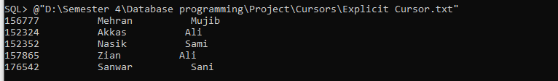

**Explicit cursor application**

**Using cursor to see the customer id, customer username of the customers from customer table using %notfound and application of loop**

set serveroutput on

set verify off

Declare

cursor C1 IS select Customer_Id, Customer_username from customer;

vc_Id customer.Customer_Id%type;

vc_Uname customer.Customer_Username%type;

begin

open C1;

loop

fetch C1 into vc_Id, vc_Uname;

exit when C1% notfound;

Dbms_output.put_line (vc_Id ||'---------------'|| vc_Uname);

end loop;

close C1;

end;

/

Result after the execution

